Road Safety Score Predictive Modeling for Smart Bases: 

Fort Carson, Colorado

Final Report

Fall 2022





# Table of Contents

**Table of Contents** **2**

**Executive Summary** **3**

**Background** **4**

About the Client 4

**Project Objectives** **5**

Introduction 5

Key Stakeholder 5

Deliverables 5

**Value and Business Impact** **7**

**Project Methodology** **8**

Dashboard Implementation 8

**Data Analysis** **10**

1. Datasets 10

Waze Data 10

Crash API 10

Weather API 11

2. Exploratory Data Analysis 12

3. Data Integration 15

**Model** **16**

1. Initial Model 16

2. Final Model 16

Training dataset 16

Model Selection 17

Model Evaluation 17

Translating Crash Label to BRAG Score 18

3. Outcome 19

**Conclusion and Recommendations** **23**

**Lessons Learned** **25**

**Suggestions for Future Work** **26**

# Executive Summary

In this report the US Ignite Fort Carson Fall 2022 Capstone team will elaborate on the client’s asks and deliverables, our approach to data wrangling and model formation, and final recommendations and future work.

US Ignite is a nonprofit research organization that accelerates the smart city movement. Under their Smart Bases and Installation Program, they work hand in hand with Fort Carson and the City of Colorado Springs[1]. As part of this larger program, US Ignite has partnered with Carnegie Mellon University’s Heinz College for assistance in developing a model for their Traffic and Weather Predictive Model project.

The Fall 2021 CMU Capstone team built off of the Spring ‘21 team’s work, and constructed two models: a public safety crash model and a traffic congestion model, but primarily focused their efforts on congestion at the base’s main gates. The Fall ‘21 team also conducted in-depth policy research on solutions to solve congestion. Leaping into this project, the next steps for us were to understand the datasets we have, frivolously research the background on Fort Carson, and build a predictive crash model with inspiration from the previous team.

After extensive research and sandboxing with the datasets at our disposal, the team began working on the predictive model. Having analyzed and compared other models, our public safety model utilizes a decision tree classification model in which we take in specific roads, historical crash data, Waze jam data, and historical weather data for training. Next, we use the upcoming 24-72 hours of weather data for prediction purposes. This will predict the output of a crash in which we can convert into the relevant BRAG (Black, Red, Amber, Green) labels. This output is put into a spreadsheet for an in-depth analysis on all streets and times, and is also placed into a dashboard format for visualization on a map.

Based on our development, we noticed a few shortcomings. The first was that our model had an overfitting problem, which was primarily solved by tuning the model parameters and adding more streets and years of Waze data to the model. The second was there were far more instances of non-crash data, than crash data. To fix this class imbalance, we utilized Synthetic Minority Oversampling TEchnique (SMOTE). In a similar vein to these issues, we saw a need for more data features. This would include road grade, live tracking of snow plows, etc. We predict that these should have a large effect on the accuracy of the model

As we hand this project off to US Ignite we hope these recommendations can be obtained for the benefit of the base, as well as the city and general population.

# Background

## About the Client

US Ignite is a nonprofit research organization that focuses on optimizing smart cities. For this project, US Ignite has been working with Fort Carson which is based in Colorado Springs. The Fort Carson Traffic and Weather Prediction Platform analyzes traffic and weather data in real time to optimize responses to inclement weather and traffic incidents at Fort Carson in Colorado Springs, Colorado. With over 30,000 daily commuters to the base and only 7 main gates in which traffic can flow through, congestion and crashes are frequent in the surrounding roadways. Thus, a solution is needed to reduce congestion, crashes, and injuries.



# Project Objectives

## Introduction

**The primary objective of our project is to make the decision making process** of choosing to close the base early, delay the opening of the base, and shutting down the base for the day, **easier** for the Garrison Safety Officer. We accomplish this objective through two main deliverables: a script and dashboard.

## Key Stakeholder

The key stakeholder for our project is the Garrison Safety Officer. The role of the Garrison Safety Officer involves consulting with his/her Traffic Managers, gathering information on the upcoming weather, and ultimately deciding on whether or not to close the base early, delay the opening of the base, close the base for the entire day, or to keep the base open.

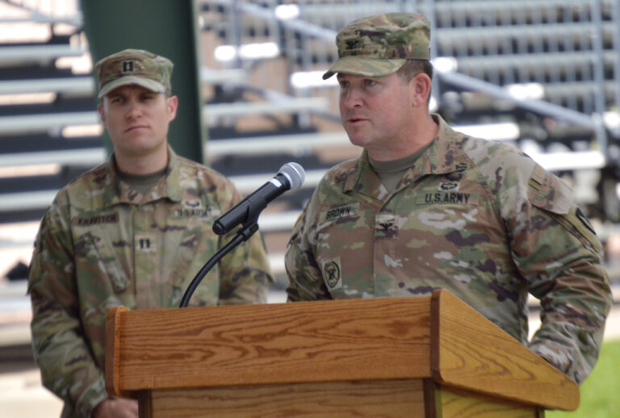

***Col. Sean M. Brown, commander, U.S. Army Garrison Fort Carson***

## Deliverables

The aim of our first deliverable is to train a predictive classification model on a few datasets in order to predict the probability of a crash for a set of roads. These probabilities are defined for each 3rd hour of the day starting at midnight given the upcoming weather forecast, which are then translated into a safety score metric: BRAG (See Figure 1).

*Figure 1: BRAG Condition Rating Score[2]*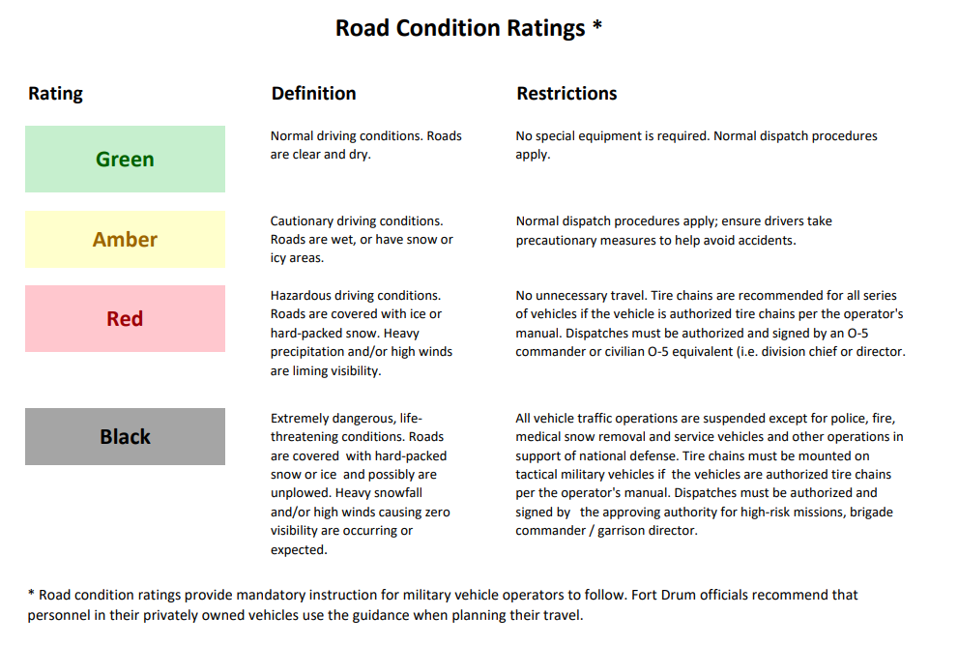

This safety score metric is used by the army for a multitude of reasons, but one use is a road condition safety metric. This acronym stands for Black, Red, Amber, Green, and is an indicator for amount of risk, aka. how safe a road is at a given time with Black having the most risk, and Green having the least risk. The final output for our scores for each road and hour are placed into a spreadsheet for ease of viewing.

Our secondary deliverable of this project is to create a dashboard to serve as a visual aid for the end user. This dashboard connects with the Google Maps API to implement the BRAG score onto the relevant roads. Further explanation of this deliverable is provided in the Project Methodology section.

# Value and Business Impact

The value and business impact of our project stems from speeding up the process of the decision-making process mentioned above. The status quo typically involves base training at roughly 5:30 A.M., and thus the commute times for personnel can start at 4 or 5 A.M. This means that the Garrison Safety Officer would be required to wake up at 2 A.M. to consult with his Traffic Managers on the status of relevant roads in order to post the decision on an announcement board before too many personnel begin their commute. With our project, we enable the Garrison Safety Officer to make this decision the night before or even two nights before.

Thus, our value and business impact is seen through three distinct ways:

**1) Makes the Garrison Safety Officer’s life easier by fast tracking the decision-making process.**

**2) Boosts base productivity by reducing military personnel’s time wasted on the road during inclement weather.**

**3) Reduces crashes and by extension, injury and/or death of both military personnel and civilians.**

# Project Methodology

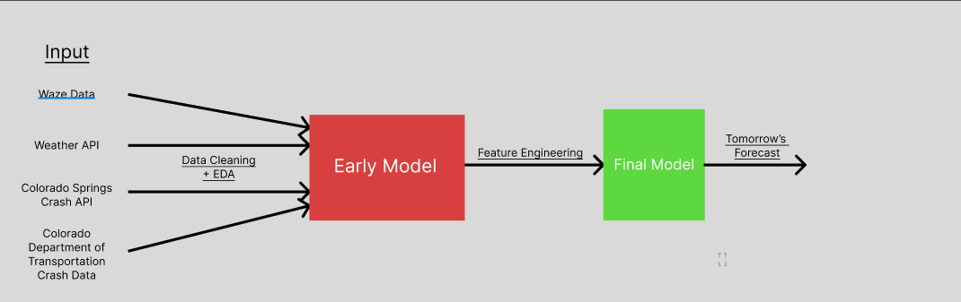

*Figure 2: Model Formulation*

## Dashboard Implementation

For the dashboard, we used Python, JavaScript, HTML as the programming languages. Django servers as the web structure and we implemented Google Map API to display the safety condition in a visual format. The dashboard is also deployed to an AWS EC2 cloud server.

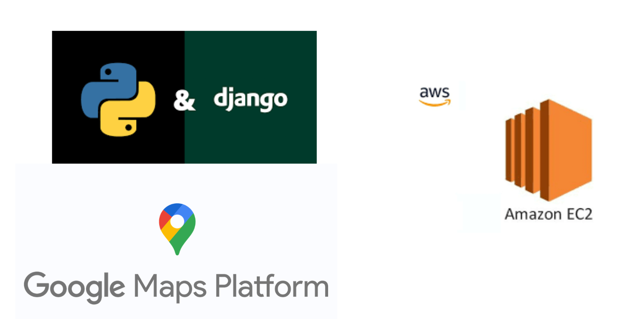

*Figure 3:Tech Stack*

The web platform format provides lots of advantages for current usage and future expansion: accessibility, in which the dashboard can be accessed from any device with an internet connection; scalability, in which it can easily scale up to meet the needs of its users; simplicity, which users can simply log in to the platform through their web browser and start using it right away.

The website is implement with Django framework, which is a high-level Python web framework that encourages rapid development and clean, pragmatic design. It provides feature such as tools for optimizing the application's performance and a robust security system that helps you prevent common web vulnerabilities.

# 

# 

# 

# Data Analysis

## 1. Datasets

### Waze Data

Waze automatically calculates traffic jams by comparing current road conditions with historical road data. When traffic on a segment is below average speed for that time of day/week, we identify it as a slowdown or jam. These are then compared with user GPS signals and user reports. Every datapoint on waze gave information regarding traffic accidents, hazards, construction, potholes, roadkill, stopped vehicles, stopped vehicles, objects on roads, and missing signs. However, upon taking a close look at our project objective, we decided to keep only the relevant columns in our dataset. These are the speed, street, timestamp of occurrence and the jam level on the road during the incident. This data was collected for a period of four years from 2019 to 2022. Only the later months of 2020 were considered so as to prevent the pandemic’s effects.

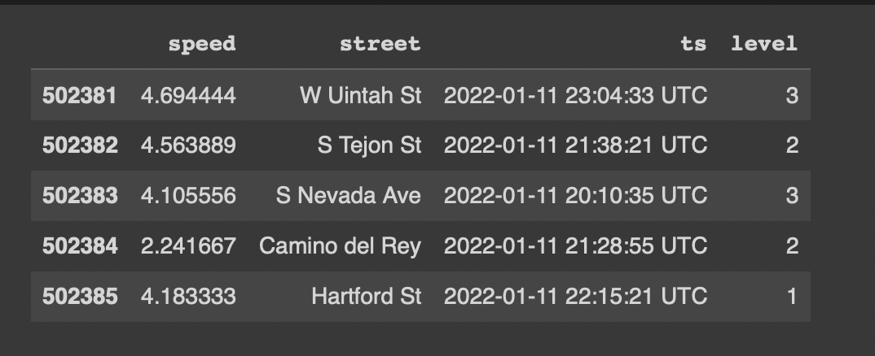

*Figure 4: Waze Data Sample*

### Crash API

API data comes from the Colorado Department of Transportation (CDOT), which includes detailed statistics on crashes in Colorado in recent years. It includes the time and location of crashes and weather conditions, as well as the damage to transportation. In our project, we focused on the time and place of occurrence.

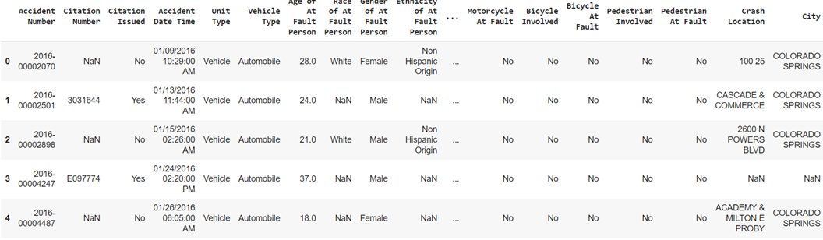

*Figure 5: Crash Data Sample*

Previously, we chose the csv dataset provided by CDOT, but since it covered too few years, we eventually turned to API data. For the crash api dataset, we first unified the format of the timestamp by rounding it to the nearest hour. Second, because there are many location columns containing roads that are not unique, we transformed them into multiple columns containing only one road per column by string manipulation. If one of these accident locations has a road in our target road dataset, we will keep this row. For the corresponding roads, we also unify their expressions by means of regular expressions.

### Weather API

The weather data comes from the open weather api, which includes both numerical data such as temperature and pressure, and categorical data such as weather and weather descriptions. For numerical data, we normalize the data in the model, and for categorical data, we use one hot encoding to make it fit the model better. Similarly, for the timestamps, we merge and round them to make them consistent with the time format of other datasets.

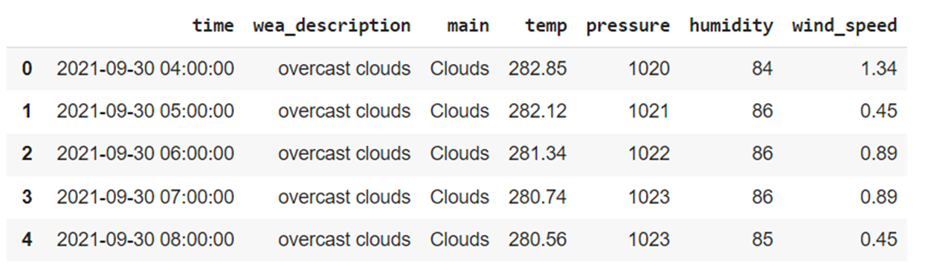

*Figure 6: Weather API Sample*

## 2. Exploratory Data Analysis

Upon taking a closer look at Waze data, we find many interesting patterns and results. Firstly, as seen in the visualization below, the streets I-25 and S Nevada Ave contribute to over 40 percent of the data points. This is interesting since these both streets are the largest in terms of commute to the Ft Carson Base. Our model can do a good job since we have interpretable data.

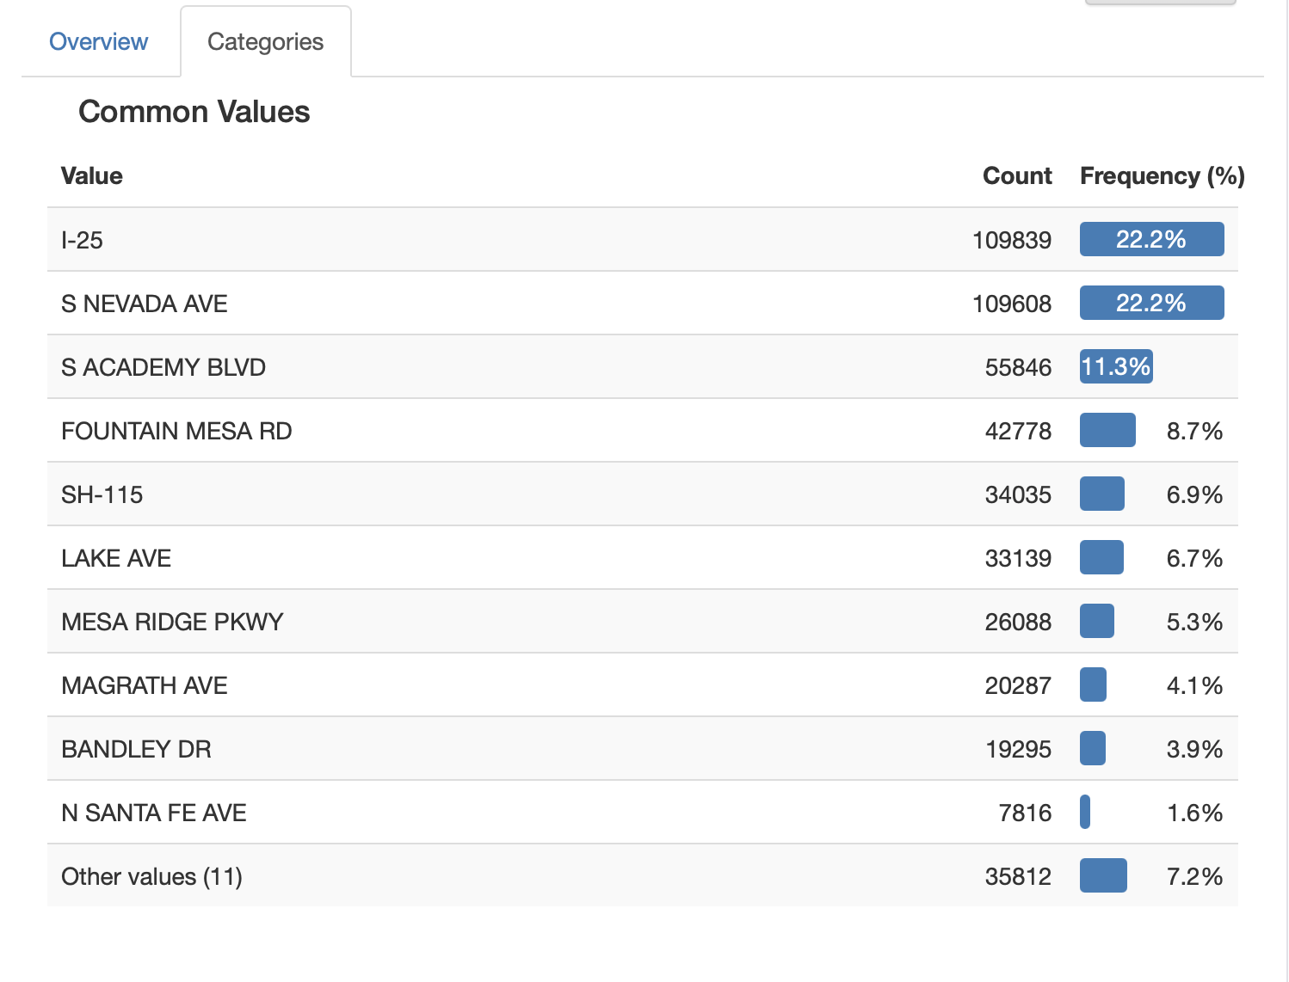

*Figure 7: Waze EDA*

Moreover, looking at the jam level distribution in the data, as seen below, we can see that most roads have a jam level of 3 in and around Fort Carson. Moreover, it appears that there is a lot of movement in general on these roads in particular.

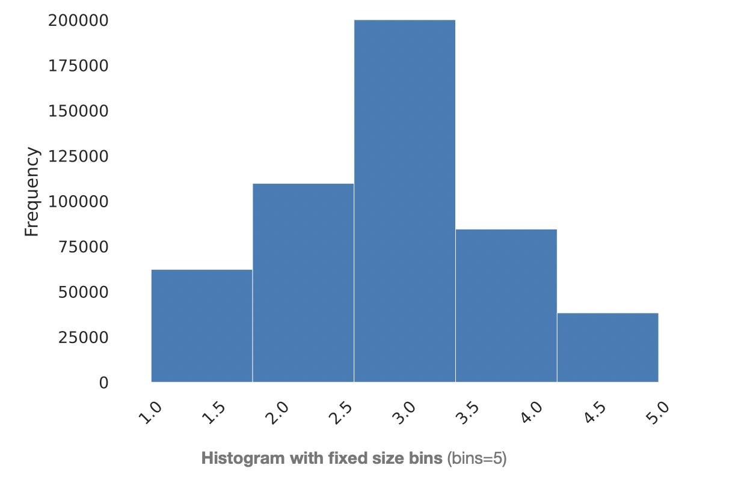

*Figure 8: Jam Distribution*

However, one important problem that we noticed when we performed EDA on Waze data was that a lot of speed entries in the data were a glaring zero. We assume that speed is one of the most important factors to predict the occurrence of a crash on these roads. So, there needs to be a good representation of this particular feature. In order to resolve this problem, we took the median of historical data grouped into hourly intervals for every street and inculcated these values in place of the null values.

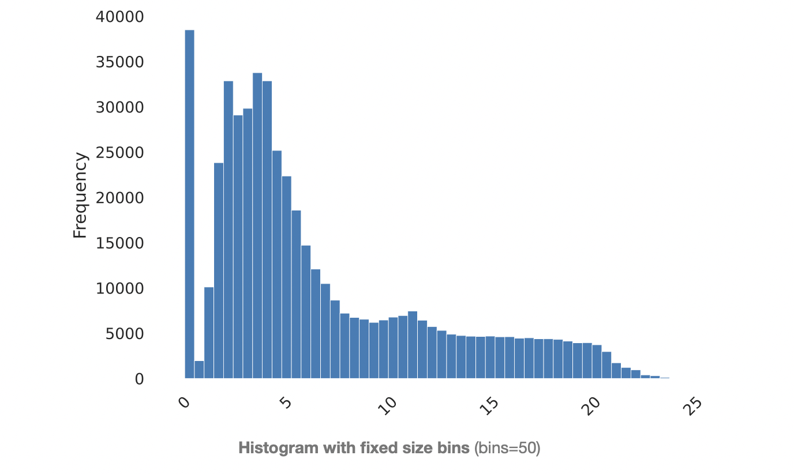

*Figure 9: Speed Distribution*

If we categorize the number of crashes in Colorado by weather, we find that, intuitively, crashes occurring in dry weather account for the majority of crashes. It should be noted, however, that although icy, snowy, and wet are not a large part of the total number of weather, they are still accompanied by a significant number of crashes, which is an important reason for including weather in our model. Overall, the weather pattern in Colorado was more stable over the three years from 2017-2019, which provided the basis for introducing weather as an important indicator.

If we turn our attention to the relationship between time of day and the occurrence of crashes, we find that crashes occur more intensively at certain times of the day. For example, more crashes occur between 7-8AM in the morning and between 4-6PM in the afternoon, during the morning and evening rush hours. Therefore, we rounded all timestamps to the nearest hour to reflect the time characteristics of the accident and added it to the model.

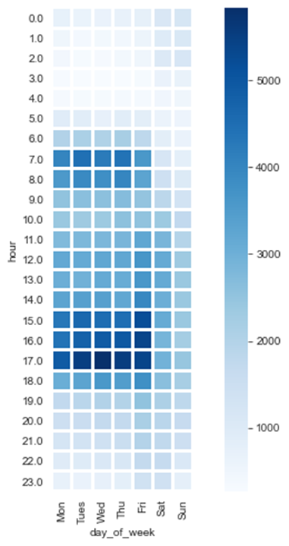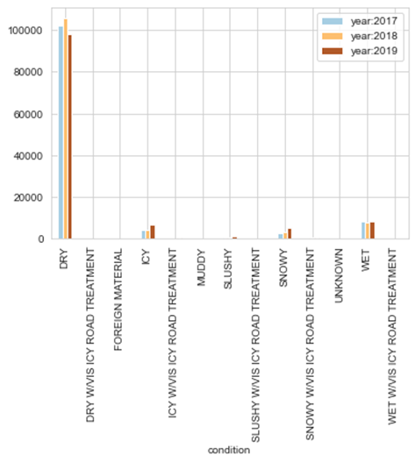

*Figure 10: Crash Distribution over Weather Figure 11: Crash Distribution over Day of the Week*

There are also correlations between columns of the data set, for example between whether it is a highway and the driving speed. Since the dimensions in the dataset are inscribed on the same topic, such correlations are inevitable. Therefore, we will weaken the impact of this correlation on the model itself by manually selecting columns during the modeling process.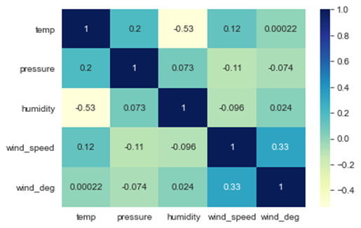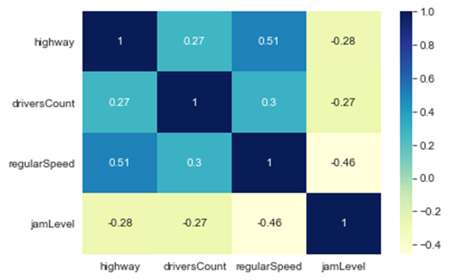

*Figure 12: Correlation Matrices*

## 3. Data Integration

After processing all the datasets, we will output the final dataset. Overall, the dataset is divided into two parts, one is the regular basis data portrayal, which includes traffic data provided by waze and weather data provided by openweather api, this part of the dataset includes the conditions at all time points, whether there is a crash or not. The other part of the dataset from the Colorado Department of Transportation includes only crash-related data.

For weather and waze data, we merge the two together by timestamp. And for crash data, we add the road name information in addition to the timestamp. And we merge these three datasets together by outer join. Finally, we created the crash label column, if a crash occurred, then it is recorded as 1, and vice versa as 0. This will be our final modeling dataset.

*Figure 13: Data Merging*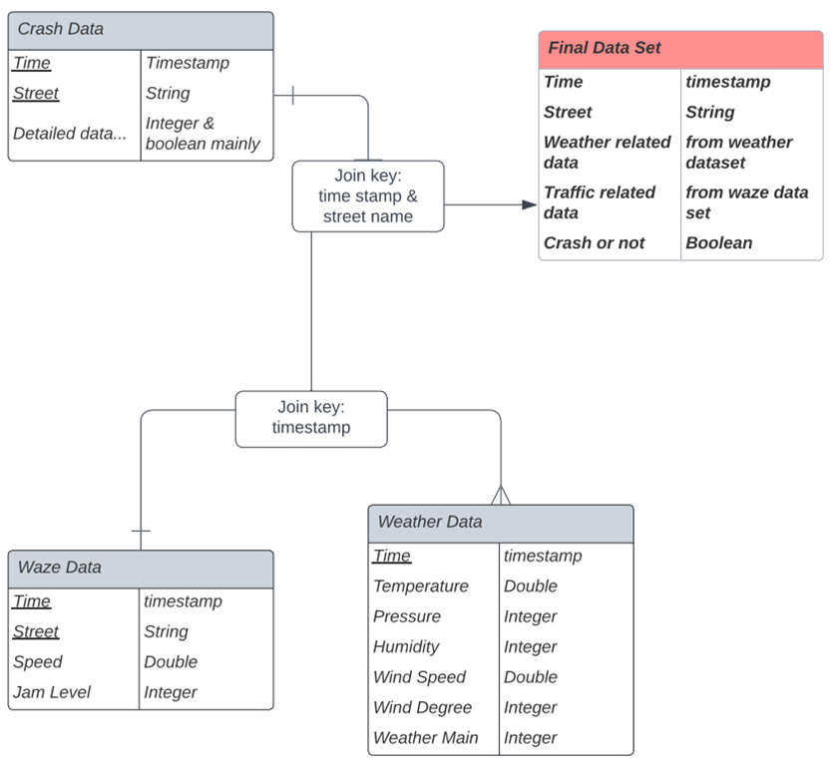

# Model

## 1. Initial Model

For the initial model, we used Decision Tree Algorithm on the merged dataset. The reason for selecting the algorithm was its interpretability for the users. We one-hot encoded the categorical features and removed features such as rain_1h, rain_3h, snow_1h and show_3h from the weather dataset as missing values constituted more than 80% of each column. On training the dataset with the aforementioned algorithm, we obtained an f1_score of - 0.98953 for test data and 1.0 for train data. On tuning the model to have a maximum depth of 8, the f1_score had dropped to 0.88791 for the test data and 0.90780 for train data,

In another iteration, we included more streets in the crash and waze dataset and used an ensemble model, to be more precise, Gradient Boosting Algorithm, to deal with columns with a huge number of missing values. On doing so we obtained an f1_score of 0.98 for train and test data.

## 2. Final Model

### Training dataset

For the final model we used the same crash and weather data for the initial model. However, from the waze data, we used only the jam level and timestamp. In addition, in order to model any effect the timestamp may have on the data, we extracted the features such as month, week of the year, day of the week, day of the month and hour of the day in the dataset and dropped the actual timestamp column while retaining these features.

The final features included in the model were -

**temp** : Temperature at the given timestamp

**Pressure** : Pressure at the given instant of time

**Humidity** : Humidity at the given instant of time

**Wind_speed** : Wind speed at the given instant of time

**Wind_deg** : Wind degree at the given instant of time

**Weather_main** : Type of weather - Clouds, Rain, All Clear etc.

**Street** : Streets around Fort Carson Being taken into consideration

**Level** : Jam level

**month** : Time feature

**week of the year** : Time feature

**day of the week** : Time feature

**day of the month** : Time feature

**hour of the day** : Time feature

### Model Selection

Again, for interpretability, the decision tree algorithm was used. However, on label encoding the categorical features and running the model, we obtained an f1_score of 0.64767 and 0.99574 for test and train datasets respectively. On exploring further, we identified that the dataset was suffering from class imbalance, where the no-crash to crash ratio was 42991:1620.

To fix the aforementioned issue, we used SMOTE to oversample the minority class hence making the number of no-crash and crash labels 42991 each. The reason for using SMOTE is it uses k-nearest neighbors to come up with a sample for the minority class. Finally, we used the decision tree algorithm with a max depth of 8 to train the dataset.

### Model Evaluation

On training and predicting, we obtained an **f1_score** of **0.86325** for the test data and **0.86641** for train data. The f1_score did not indicate any overfitting or class imbalance.

On examining the features influencing this model, we had the feature importances as follows -

*Figure 14: Feature Importance*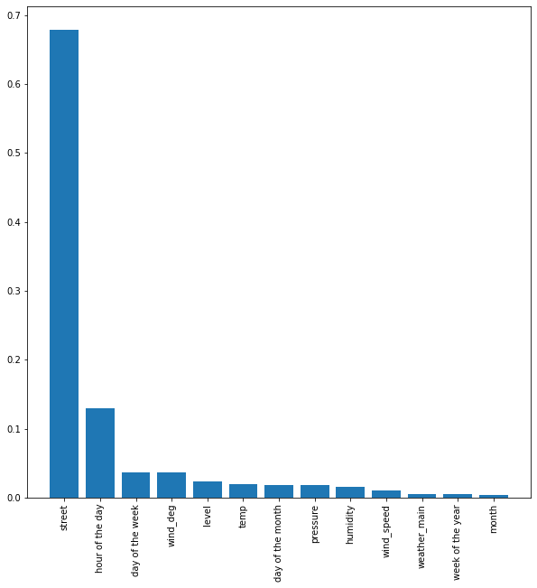

From the graph we observe that the street, hour of the day and day of the week played a major role in deciding the outcome of the model. It is quite intuitive as the behavior of each street is different and so the probability of crash would also vary accordingly. The hour of the day day and day of the week often influence the activity on a given street as it may be more likely for a crash to happen due the wee hours of the day as the commuters may speed the most then or during the rush hours as commuters would be the most impatient then.

### Translating Crash Label to BRAG Score

Classification algorithms like the decision tree give us the flexibility of predicting the label for a given record along with the probability of classifying the data record as crash or no-crash. We used this probability score as the BRAG score required for our solution.

The probability scale of 0-1 was divided into four slabs to designate a color to each slab which was then fed as an input to the dashboard. These slabs are as follows:

* Black: [0.9, 1]
* Red: [0.75, 0.9)
* Amber: [0.5, 0.75)
* Green:[0, 0.5)

## 3. Outcome

As the project outcome, we developed a web-based platform that displays the *‘BRAG’* score predictions for all the roads we selected associated with the Fort Carson Command for up to 72 hours. Below figure illustrates all the predicted *‘BRAG’* scores for each street using the trained model combined with the forecasted weather.

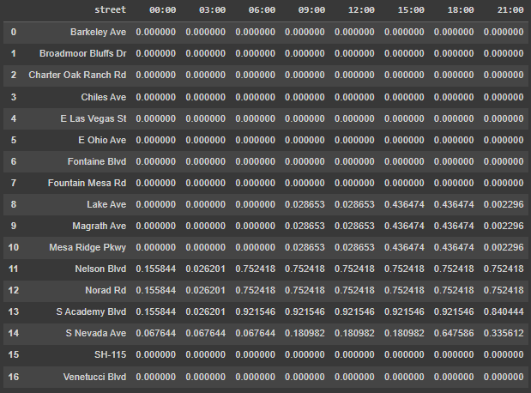

*Figure 15: Probability of Crash based on Time and Road*

Using the generated values, the dashboard is updated accordingly to be showcased in the Dashboard. The dashboard consists of a navigation bar that provides users with different selections and a map that visualizes the safety score predictions. For the map section, we integrated Google Map API and used polylines to mark out all the roads we selected that are essential for the commute safety of the personnel at the fort Carson command.

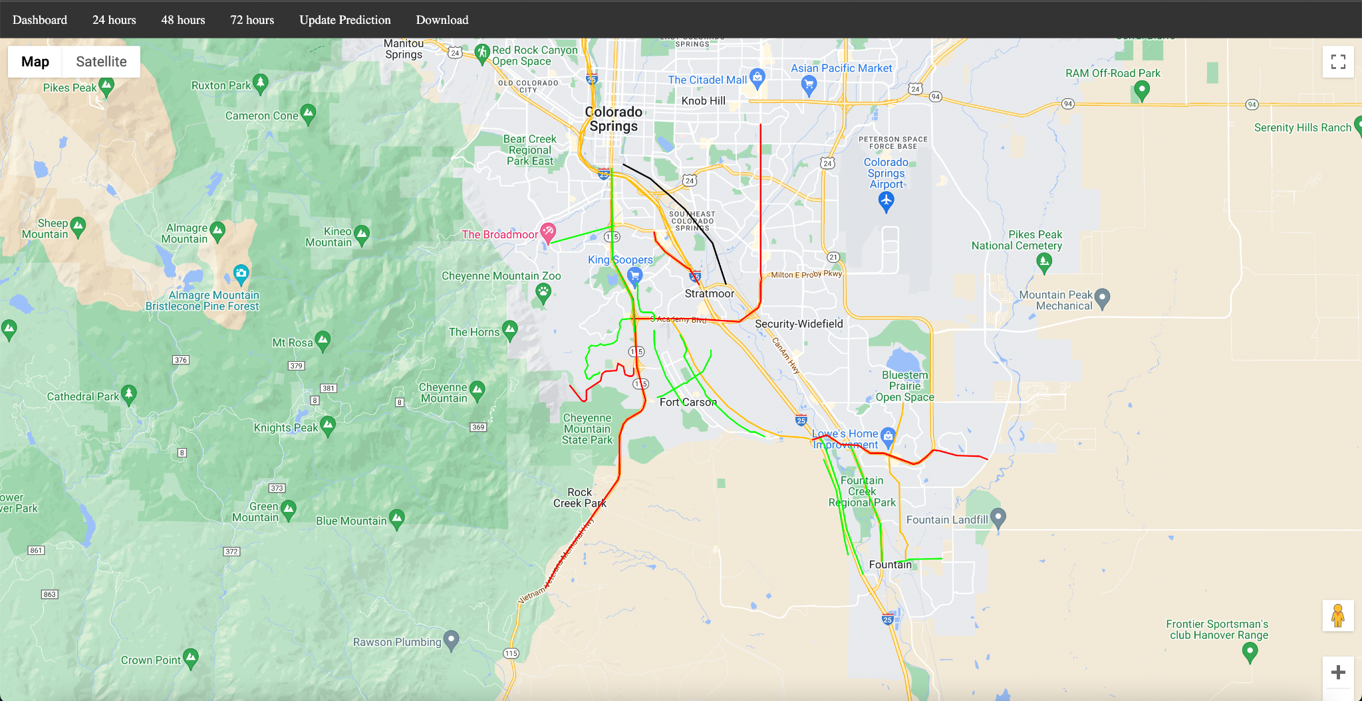

*Figure 16: Dashboard*

The map provides both 2D and satellite maps for users to view based on their needs. All the roads that we selected are marked in black, red, amber, and green based on our safety metrics and our model predictions.

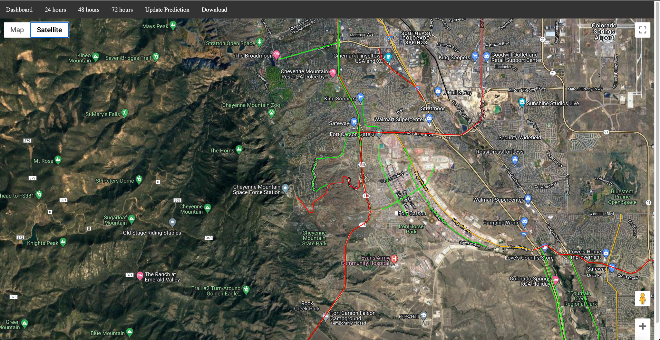

*Figure 17: Satellite of Dashboard*

For example, S Academy Blvd is marked red, which indicates a relatively low level of security based on the prediction. And users get to zoom in and zoom out and even use Google Street View just like using regular Google Maps.

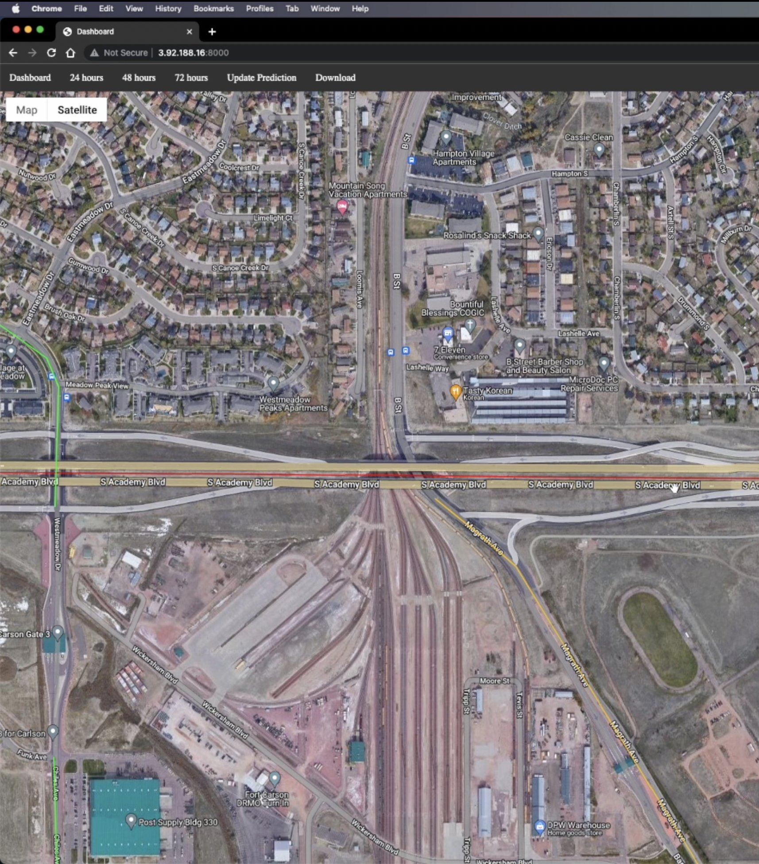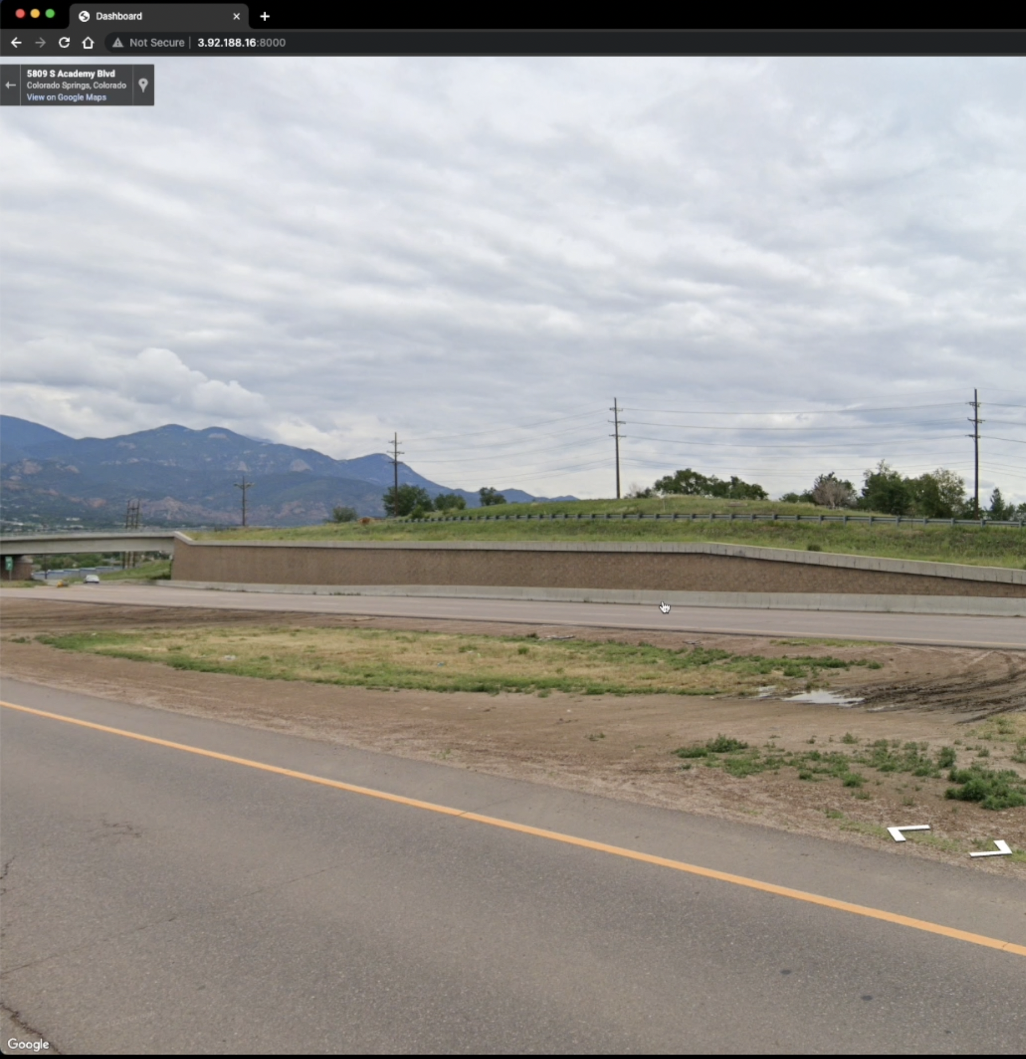

*Figure 18: Street View*

They can click on the update prediction button to update the prediction based on the current timestamp and the new data retrieved from the Open Weather API.

If the user wants to see a detailed brag prediction, they can also click download. After clicking the button, a CSV file that contains all the predictions for the next 24, 48, and 72 hours of safety prediction will be downloaded. The prediction is recorded in a 3-hour interval, which enables the user to view an in-depth and accurate brag prediction.

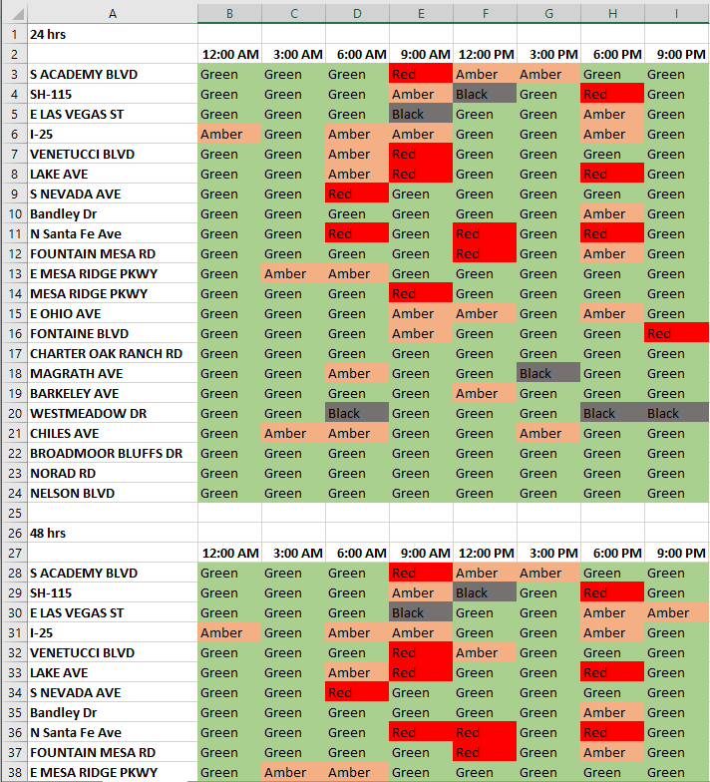

*Figure 19: Results in Spreadsheet Format*

# Conclusion and Recommendations

Applying Digital Transformation and Intelligent Data analysis infrastructure, we were able to automate manual daily tasks and provide real time data-backed assistance to the Garrison Commander at Fort Carson, thereby helping him take an informed decision to shut or open the Fort gates. The data that fuels the model has been cleaned, transformed & merged to provide valuable information for model training and real time prediction.

Overall following items highlight our deliverables for the project:

*Street level BRAG Score Prediction for next 24-72 Hours:* The BRAG Score is a metric that measures the risk level for a specific area or street. It is typically used to assess the safety of an area and to help decision-makers plan and allocate resources accordingly. A BRAG Score Prediction for the next 24-72 hours would provide forecasts of the BRAG Score for a particular street or area over the specified time period. This could be useful for decision-makers and others who need to know the expected level of risk in a specific area in the near future.

*Dashboard for the Garrison Commander:* We have developed an user interface that allows decision-makers(Garrison commander and/or other stakeholders at Fort Carson) to view and analyze data and information relevant to their responsibilities. A dashboard for the Garrison Commander would provide a centralized location for the Commander to access and review data and information related to the garrison and its operations. This could include real-time data on weather, BRAG Scores, and other factors that impact the garrison's operations.

*Real Time & dynamic prediction of weather and 3-hourly BRAG forecast for each street:* Real-time weather prediction model involves using data and models to forecast the weather for the immediate present or near future. A real-time weather prediction system could provide updates on current weather conditions and forecasts for the next few hours or days. A 3-hourly(can be modified to support hourly) BRAG forecast for each street would provide predictions of the BRAG Score for a specific street on an hourly basis. This could be useful for decision-makers and others who need to know the expected level of risk for a specific area(Fort Carson, in our case) in the near future.

These deliverables are fairly modular and portable in nature. They can be re-trained and adjusted to work with any other desired location. According to weather.com portal, “About 21 percent of those, or just over 1.2 million, involved hazardous weather.”[[3]] Inclement weather conditions can be one of the major factors for crashes, jams and road blocks. This is also seen in the model and data analysis part of the project extracted using feature importance algortihm.

The scope for extending, re-using and re-working the project is far and wide. The value of the projects extends beyond the scope and the requirement of the client.

**Recommendations**

Although the model is well tuned an robust to provide good recommendations and predictions, there is scope for improving the model further and enhance it’s capabilities. Following are some of the recommendations that one can inspect and research further to be incorporated into the project to enhance it’s scope and value:

*Use more and better quality data:* One of the most important factors in the performance of a machine learning model is the quality and quantity of the data used to train it. The more data you have, and the better the quality of that data, the more accurate your model is likely to be.

*Fine-tune the model's parameters:* Decision tree models have various parameters that can be adjusted to improve their performance. These may include the depth of the tree, the minimum number of samples required to split a node, and the minimum number of samples required at a leaf node. Experimenting with different values for these parameters can help you find the optimal settings for your model.

*Use ensembles:* Ensemble methods involve training multiple models and combining their predictions to make a final prediction. This can improve the overall accuracy of the model by reducing overfitting and improving generalization to unseen data.

*Enhance feature selection:* Decision tree models can be sensitive to the presence of irrelevant or redundant features in the data. Using feature selection techniques can help you identify and remove unnecessary features, which can improve the performance of the model.

# Lessons Learned

1. Technical

* Feature selection is a critical step in our project, as it involves choosing the most relevant and informative input features to use in training a model. There are many features in Waze, Open Weather API, Colorado Spring crash data, and Colorado Department of Transportation crash data. The selection of features can greatly impact the performance of the model, as using too many irrelevant or redundant features can lead to overfitting, while using too few relevant features can lead to underfitting. Feature selection can help to improve the interpretability of the model by reducing the number of input variables that need to be considered, and it can also help to reduce the computational complexity of the model and improve its training and prediction speed.
* Model selection and optimization are critical: There are many different types of machine learning models that can be used for safety score predictions, and it is important to select the most appropriate model for the task at hand. It is also important to optimize the model's hyperparameters to ensure that it is performing as well as possible.

1. Managerial

* From a managerial perspective, this project required a lot of to-and-fro discussion every step of the way with not just all team members, but also the client representative and the faculty advisor. This meant constantly trying to figure out what approaches to take and when to meet. A big part of this was also making sure everybody was on the same page. This was the biggest challenge that we faced as a team. The lesson learned from this experience was effective project planning and making sure we had a buffer of at least three days before any deadline or submission.
* To ensure everybody was on track while carrying out the assigned tasks, we used numerous project planning tools like Trello and Slack that made it easier for everyone to understand and visualize not just the progress of every week, but also see the contributions made by other team members. We figured this out early on in the project, and doing so saved everyone a lot of confusion and time.
* For any team to function properly, effective channels of communication are extremely important. Our team constantly pushed each other to perform and give their best to the project. This took place by creating a safe environment open to different views and discussions.

# Suggestions for Future Work

Our suggestions for future work fall into three primary categories -

1. Inclusion of Additional Features

Features like road grade, snow plow schedule/status, and vehicle type can be added to the model to improve the accuracy since these are features that can contribute greatly to the safety score of the roads.

1. Scalability

Scalability refers to the interpretability and the ability to apply the model to a different scenario and conditions. A key factor in determining whether the model is here to stay or not is the ability to apply it to any similar condition. We need to take steps in order to improve our model’s scalability and make it suitable for multiple locations. Ideally, we must be able to locate the roads around the new location, pull up all the data for those roads and perform the modeling steps without any external interference.

1. UI/UX

Lastly, the dashboard should be made more user-centric and can have numerous interactive features. This could be a good direction to work on in the future.

1. https://www.us-ignite.org/program/smart-bases-and-installations/
2. https://home.army.mil/drum/application/files/3315/3451/6680/Road_Condition_Ratings_Chart.pdf
3. https://weather.com/safety/winter/news/weather-fatalities-car-crashes-accidents-united-states